**Full Stack Development with MERN**

**Project title:** Grocery App

**Team members:** Mohammed Zaid, Naveen R, Mohammed Faisal

**Project Overview**

**Purpose:** Create a Grocery Shopping App that simplifies and enhances the grocery shopping experience. The app allows users to easily browse, search, and purchase groceries, tailoring their shopping experience based on preferences like dietary restrictions, favorite brands, and budget.

**Features:** Secure payment processing, personalized shopping lists, real-time inventory updates, and delivery tracking to streamline the grocery shopping process.

**Architecture**

* **Frontend:** Reactjs and plain css for Frontend.
* **Backend:** We used Node js for Backend.
* **Database:** We have used MongoDB for backend and respective schemas related to Grocery app.

**Setup Instructions**

**Installation:**

**Client : run npm i for installing the dependencies.**

**Server: create a database in mongoDB , then get the connection link and save it in .env**

**Folder Structure:**

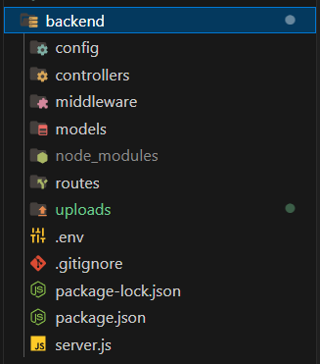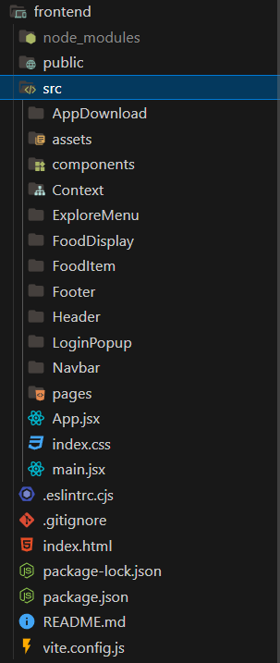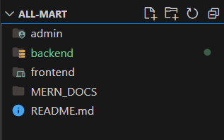

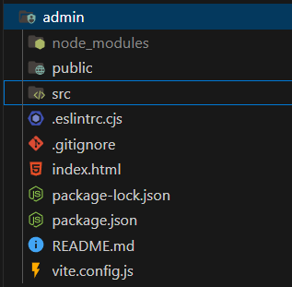

**Running the application:**

**Client:**

cd frontend

npm run dev

**Server:**

cd backend

npm run server

**Admin:**

cd admin

npm run dev

**Working of the Grocery Application:**

Landing page:

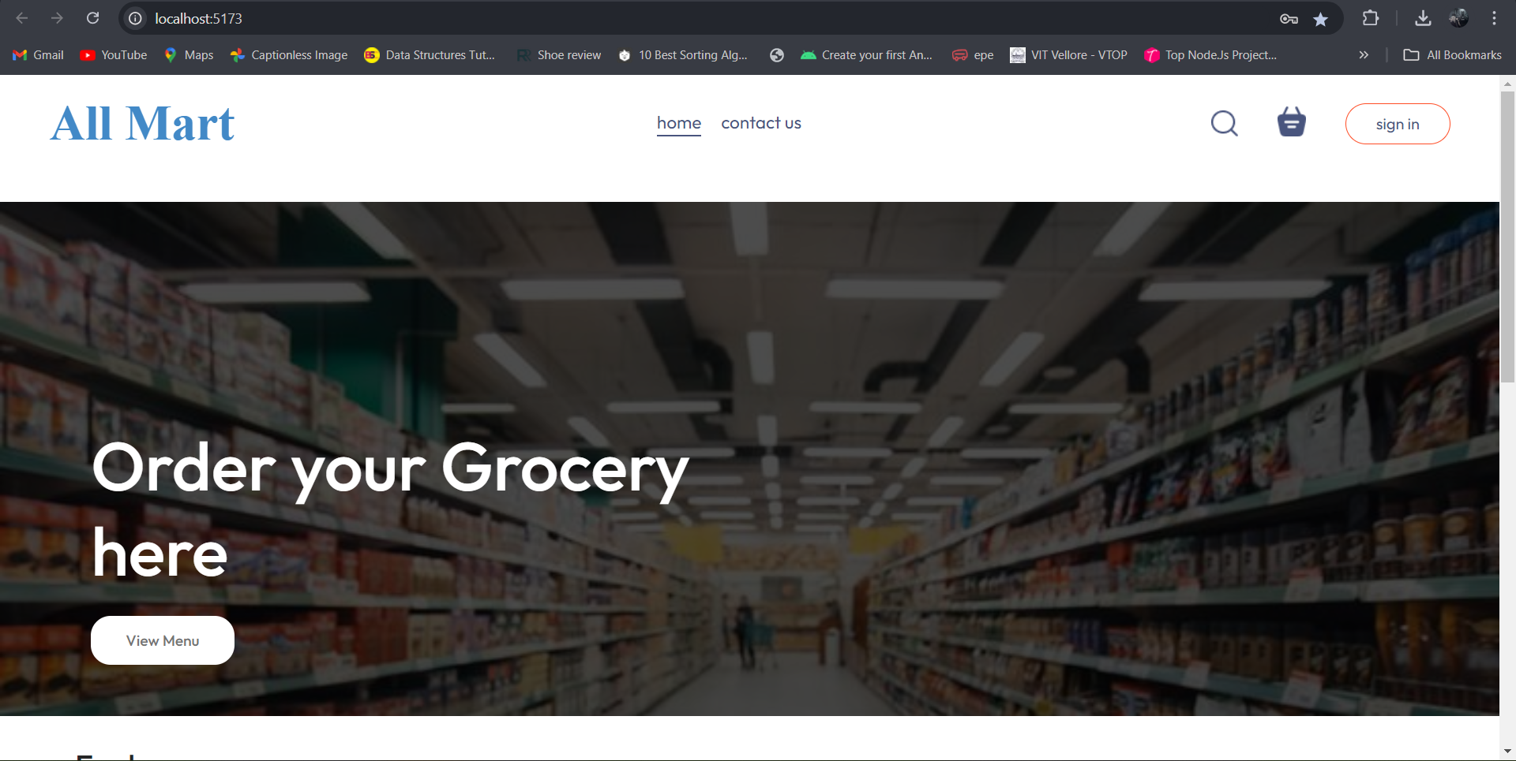

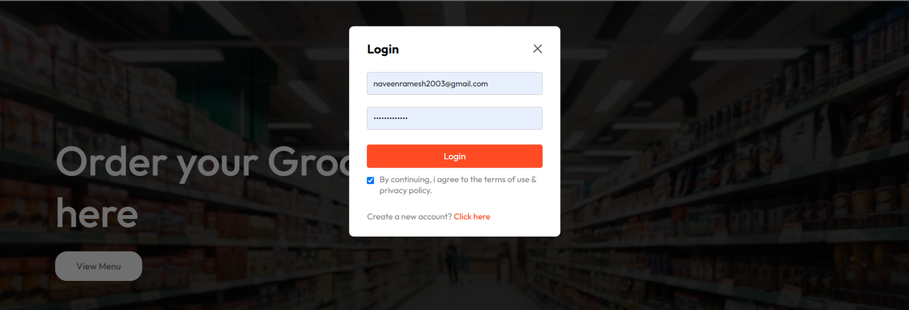

Login

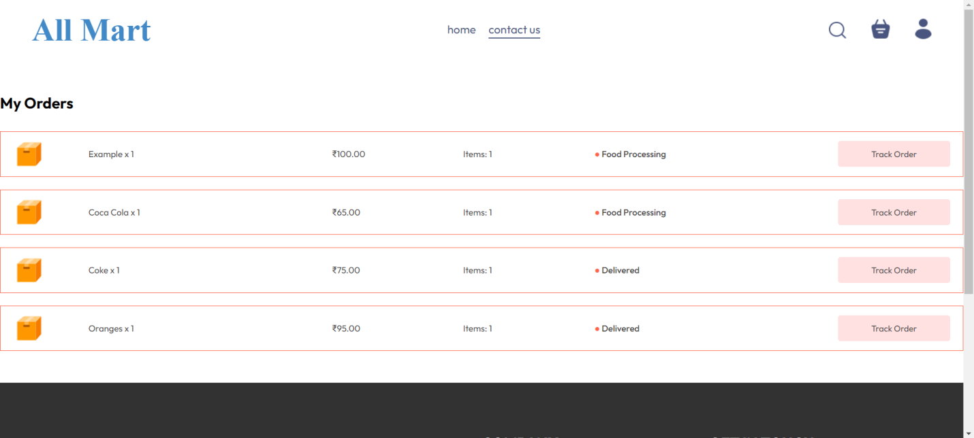

Orders page

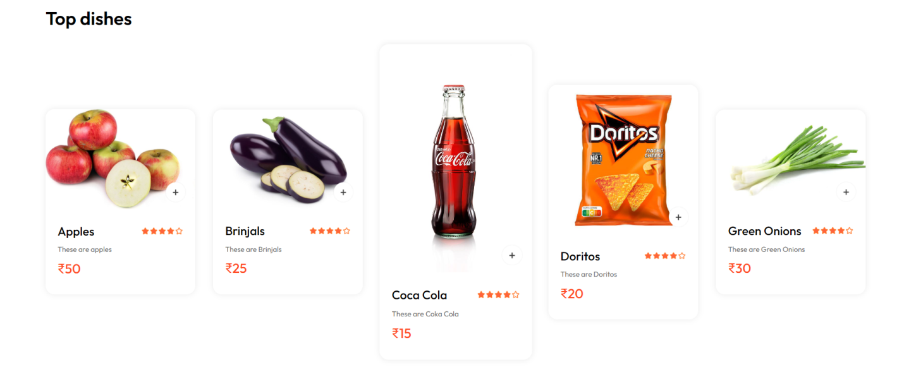

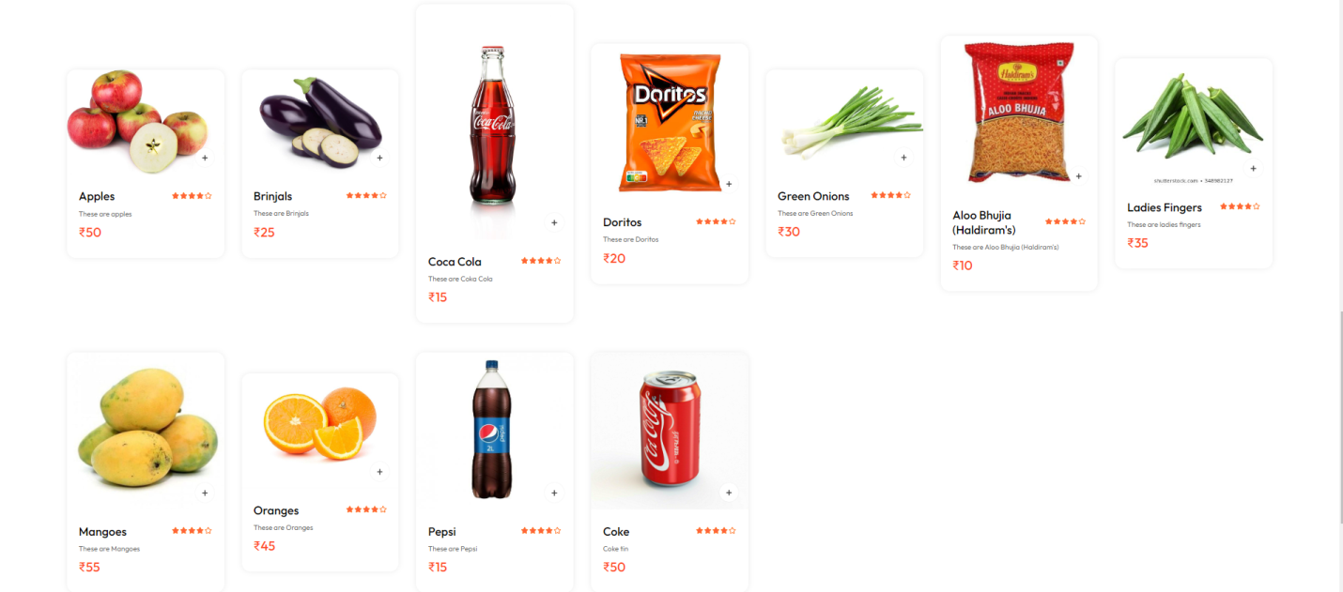

Product catalogue

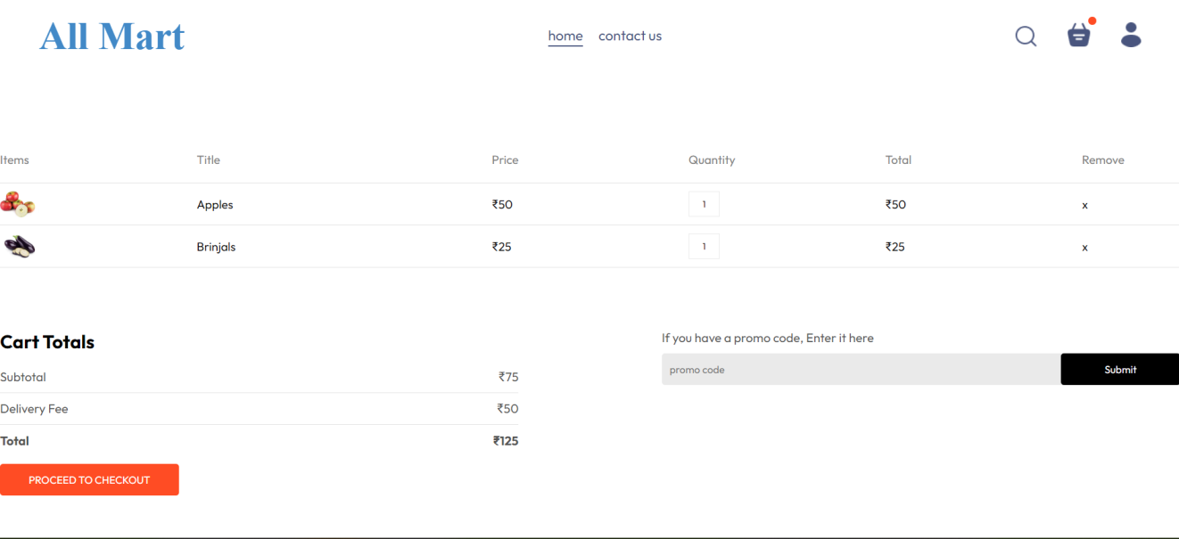

Adding to cart

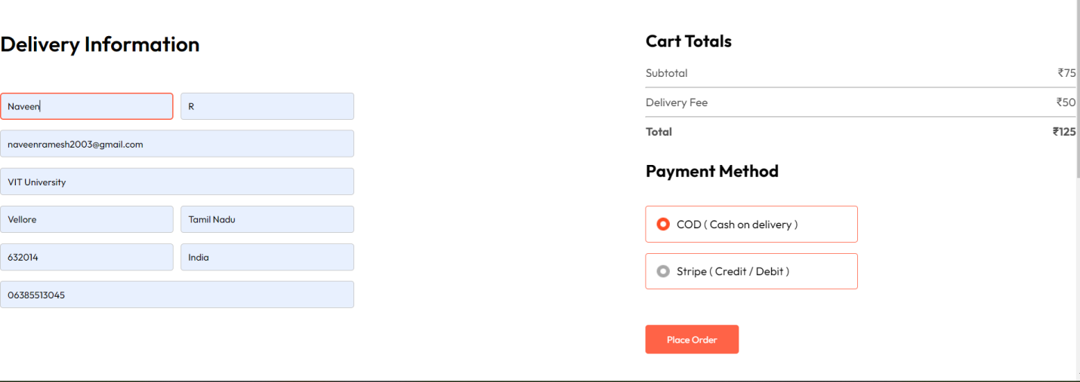

Payment info and placing order

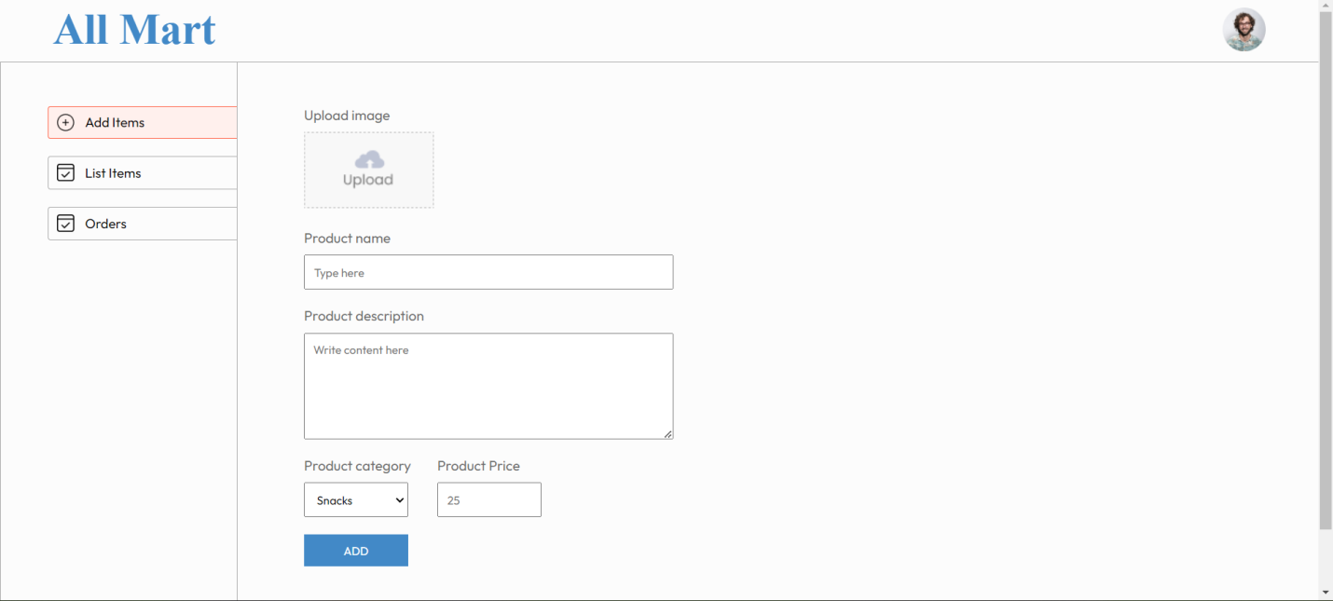

Admin adding items

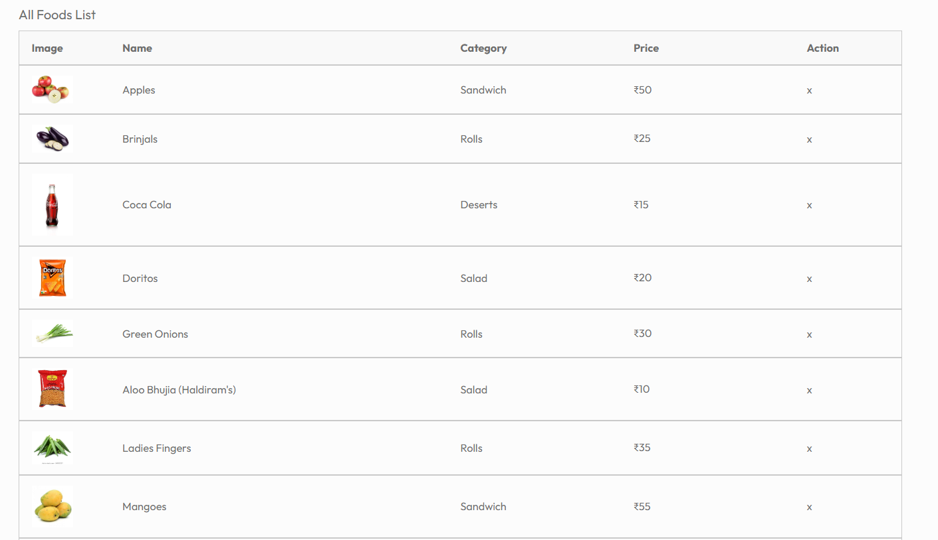

Admin removing items

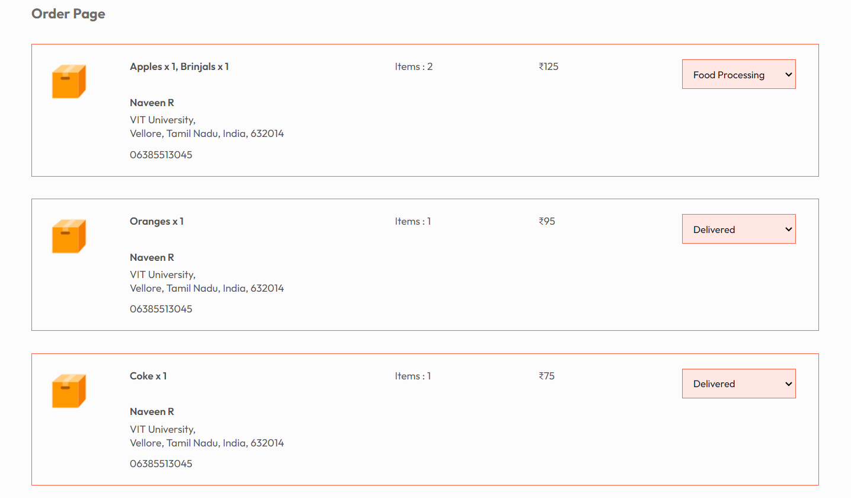

Order updating by admin



Tracking after getting updated by admin

**Future enhancements:**

Planning to include recommendations based on customer’s previous purchases.